2015-RU-01-EN A chair or an armchair?
0 ---- | I: ---- | II: ---- | III: ---- | IV: ----

Answer Type: Multiple Choice Mandatory for: none

Body
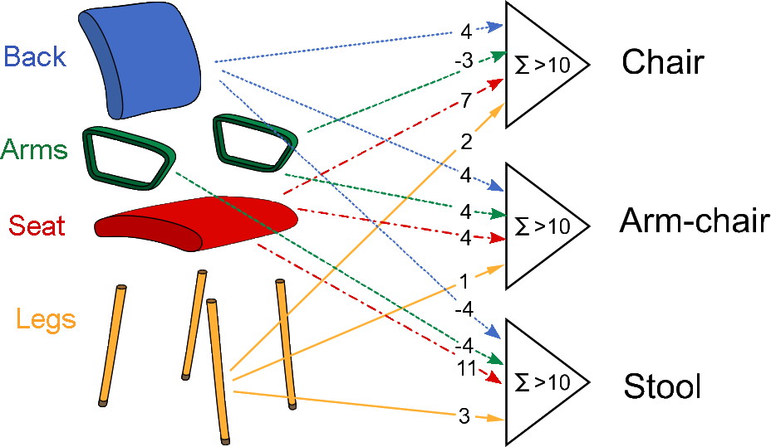
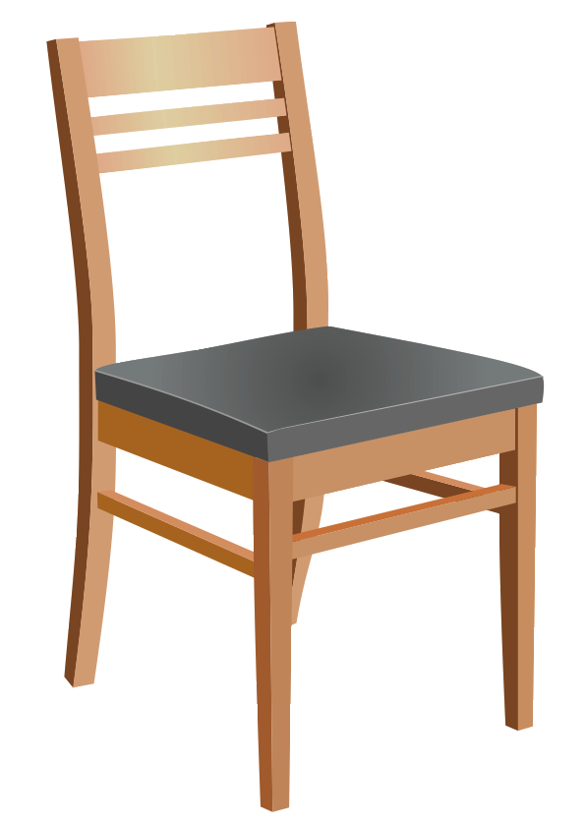
The Beaver Research Center for Artificial Indolence has devised a recognition system for resting furniture based on 3 “neurons”. They consider the parts of the object by summing up points (accordingly to the numbers shown in the left picture) if it has a back, arms, a seat, or legs. Neurons recognize chairs, arm-chairs, or stools when for one of the neurons the sum exceeds 10, and for others it is less or equal than 10.
For example, the object on the right has a back, no arms, a seat and legs. Hence, it gives 13 points on first neuron, 9 on the second and 10 on the third. Therefore it will be recognized as a “chair”.

Question

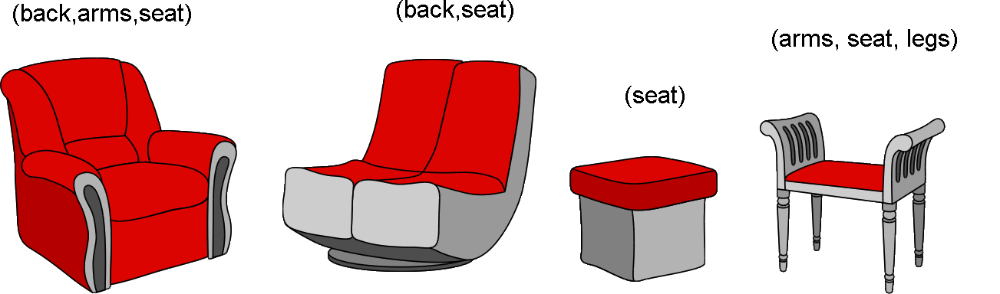
Which of these objects will NOT be recognized by the recognition system?

Answer

Explanation

Correct answer: the last object on the right.
The first object has the following attributes: back, arms, seat and no legs.
Weights for different types of species will be:
chair –> 4-3+7=8, arm-chair –> 4+4+4=12, stool –> -4-4+11=3
therefore it will be recognized as arm-chair.

The last object has attributes: arms, seat and legs.
Weights for different types of chairs will be:
chair –> -3+7+2=6, arm-chair –> 4+4+1=9, stool –> -4+11+3=10
therefore no one of alternatives is appropriate for such types of chair.

For other two species weights will be:
chair –> 4+7=11, arm-chair –> 4+4=8, stool –> -4+11=7
chair –> 2, arm-chair –> 4, stool –> 11

It's informatics

The recognition of objects as members of a class of items is not an easy task. What is a “rose” after all? The features relevant to tell a rose from a pig are not necessarily useful to distinguish roses and tulips: the recognition is much simpler if the set of objects to recognize is fixed in advance. This simplified problem is called classification. In the task the system is designed to classify any object into one of four categories: chairs, arm-chairs, stools, or others. The neurons are simple components that compute a sum and activate if the result is greater than a threshold (and indeed this trivial model is surprisingly similar on what biologists actually know about brain neurons!): the numbers they sum are sometimes called the weights of the inputs since they establish the importance of each feature in the classification task. For example, having a seat is a very important feature in stools, and legs are almost irrelevant for arm-chairs.
All in all, a neuron is a compact way to express an otherwise complex rule: since all the inputs are just binary (true/false) properties, you can see that by writing a table with all the possibilities. For the “Chair” neuron:
 | Back | Arms | Seat | Legs | Sum | Classification
weights | 4 | -3 | 7 | 2
 | 0 | 0 | 0 | 0 | 0 | Other
 | 0 | 0 | 0 | 1 | 2 | Other
 | 0 | 0 | 1 | 0 | 7 | Other
 | 0 | 0 | 1 | 1 | 9 | Other
 | 0 | 1 | 0 | 0 | -3 | Other
 | 0 | 1 | 0 | 1 | -1 | Other
 | 0 | 1 | 1 | 0 | 4 | Other
 | 0 | 1 | 1 | 1 | 6 | Other
 | 1 | 0 | 0 | 0 | 4 | Other
 | 1 | 0 | 0 | 1 | 6 | Other
 | 1 | 0 | 1 | 0 | 11 | Chair
 | 1 | 0 | 1 | 1 | 13 | Chair
 | 1 | 1 | 0 | 0 | 1 | Other
 | 1 | 1 | 0 | 1 | 3 | Other
 | 1 | 1 | 1 | 0 | 8 | Other
 | 1 | 1 | 1 | 1 | 10 | Other
Thus, the “Chair” neuron recognizes objects as chairs only if they have Back, Seat, no Arms, and, optionally, legs.

Keywords

Classification, neural networks, perceptrons.

Websites

http://www.doc.ic.ac.uk/~nd/surprise_96/journal/vol4/cs11/report.html

Internal Use

Wording

List of word used to name important things in the task body (concepts, definitions, objects, names, etc.) This is to ensure the consequent use of terms in the task body and facilitates translation.

Comments

Ilya Posov, iposov@gmail.com, 2015-05-25, changed almost all graphics to self-drawn
Mattia Monga, monga@di.unimi.it, 2015-05-26, changed text and graphics. It'informatics and keywords.

Graphics

All graphics is self-drawn (by painter Anya Vasilkova), except the small black chair at the bottom right of the statement, it is from openclipart.org

Files

All additional files for this task (graphics, scripts, etc.)
2015-RU-01-EN.odt (this file)
2015-RU-01-EN.svg (inkscape sources)
2015-RU-01-EN-Black-and-White.svg (the black and white variant of images)
2015-RU-01-EN-wooden-chair-viyana.svg (the wooden chair to the bottom right of the statement)

Authorship

Sergei Pozdniakov, Russia, pozdnkov@gmail.com
Ilya Posov, Russia, iposov@gmail.com

License

Copyright © 2014 Bebras – International Contest on Informatics and Computer Fluency. This work is licensed under a Creative Commons Attribution-NonCommercial-ShareAlike 3.0 Unported License (CC BY-NC-SA 3.0). Visit: http://creativecommons.org/licenses/by-sa-sa/3.0/

